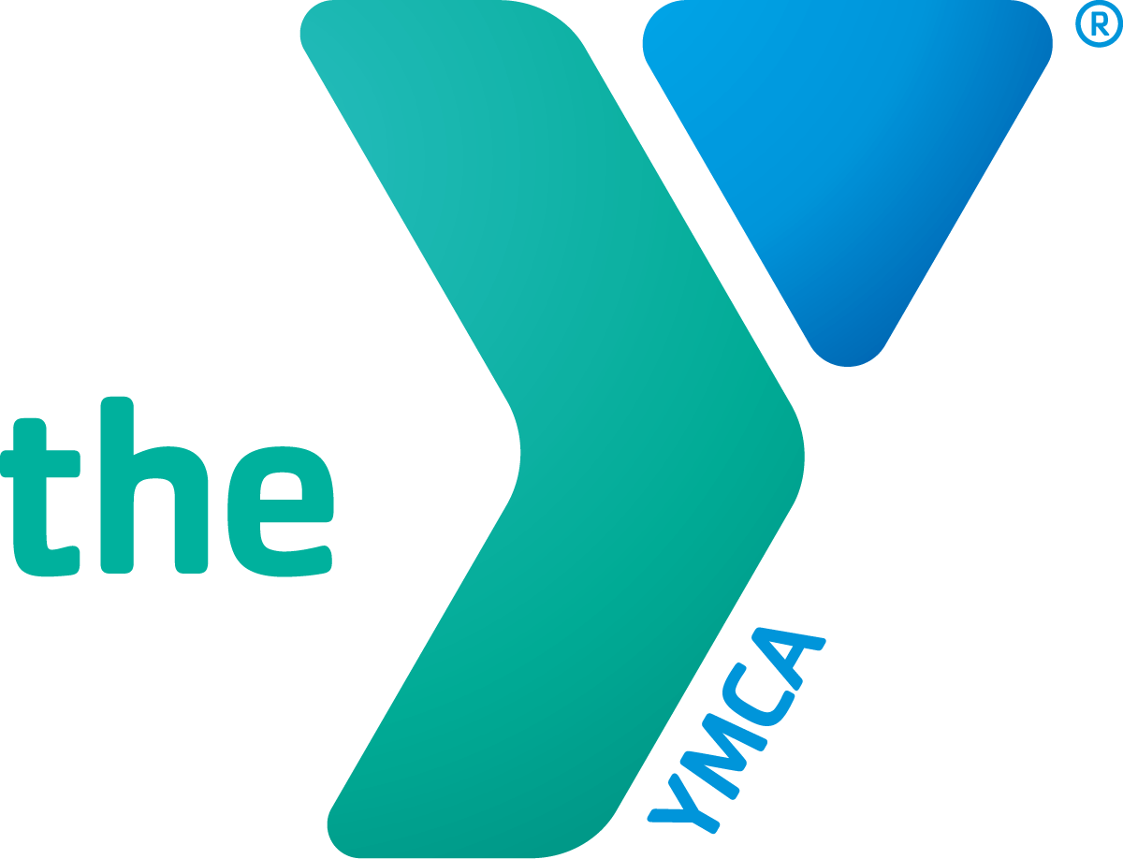

Date
Aloha e XXXX,
Greetings on behalf of the YMCA of Honolulu, an organization that I am pleased and proud to support. Let me share with you a few reasons why this is so important, and how you can join me in promoting a community of resilient youth, thriving kūpuna, and healthy families.
As one of the state’s largest providers of youth and teen programs, the Y has been a critical provider of mental wellness programming to address the ongoing mental health challenges that face our youth. With the guidance of highly-trained Y staff, teens can get the help they need from caring professionals. Your donation makes this possible.
With nearly 20% of Honolulu’s population aged 60 and older, the Y has become a place for kūpuna to make life-long friends, enjoy a free meal, increase their mobility through classes, and feel welcome and safe. Your donation makes this possible.
For working families, access to quality early learning programs for their keiki allows them to provide for their families. Your donation makes it possible for those families, who need financial assistance, to reach their potential.
There is no greater feeling than knowing that you made someone’s life richer and full of hope. Please join me in support, and make your gift today.
More information about the Y and its programs:
https://bit.ly/YMCAAnnual or scan:

For your convenience, you may make an online gift at: https://www.ymcahonolulu.org/donate.
Mahalo,
XXXX

