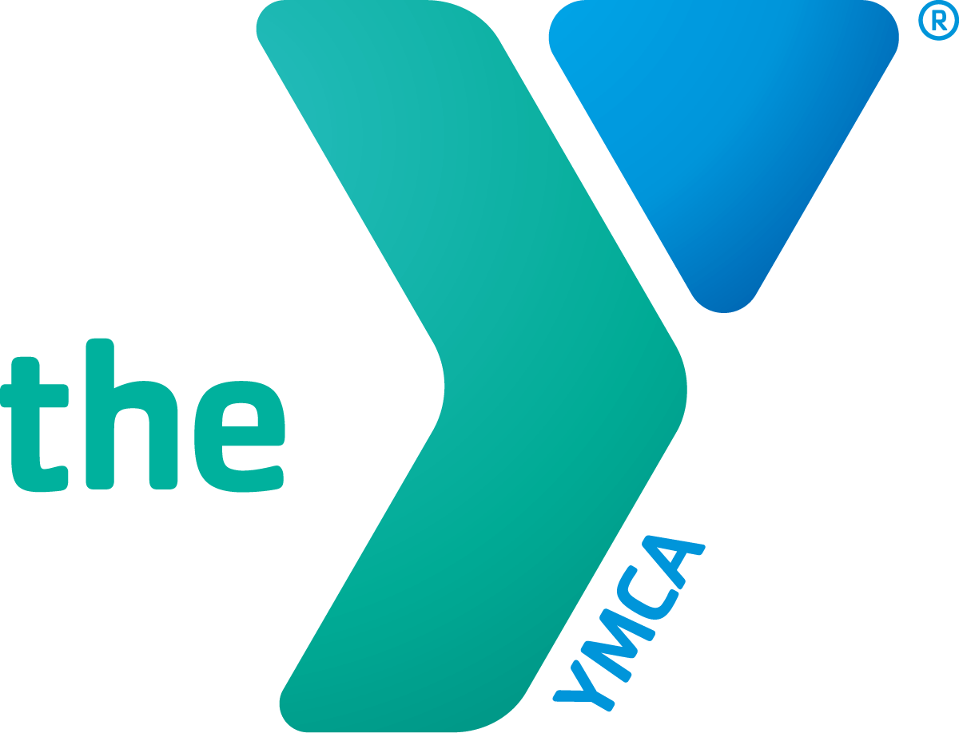
Date
Aloha e XXXX,
Greetings on behalf of the YMCA of Honolulu. It is that time of year when I have the pleasure of reaching out to you to join me in giving to a cause that, I hope you will agree, is worthy of your generous support.
Your past donations have helped so many people improve their situations and build a better future. You will be pleased to know that your 2024 Annual Campaign will support individuals and families who can’t afford our programs, such as the following:
- Mental wellness programming to address the ongoing mental health challenges that face our youth. With the guidance of highly-trained Y staff, teens can get the help they need from caring professionals.
- Kūpuna programs to improve their health and mobility, provide them with nourishing meals for free, and provide a welcoming place where they can gather and connect with others.
- Access to high-quality, early learning programs so that their families can reach their full potential knowing that their keiki are in a safe and nurturing environment.
There is no greater feeling than knowing that you made someone’s life richer and full of hope. Together, we are changing lives for youth and teens, kūpuna, and families.
We are truly grateful for your generous donation last year. Can we count on you again this year?
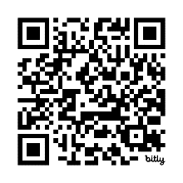
For your convenience, you may make an online gift at: https://bit.ly/YMCAAnnual or scan:

Mahalo,
XXXX

